
Quality Assurance Engineer

Fixed Term Contract

Application pack – April 2026

Dear Candidate,

Thank you for your interest in this post and in the Mental Welfare Commission.

Our Mission is to be a leading and independent voice in promoting a society where people with mental illness, learning disabilities, personality disorder, dementia and related conditions are treated fairly, have their rights respected, and have appropriate support to live the life of their choice.

It is an exciting time to join the Mental Welfare Commission: challenging and promoting change, focusing on the most vulnerable, increasing our impact and improving our efficiency and effectiveness.

This is an opportunity to contribute to a national organisation focussing on the rights of individuals. For details of our recent work including our reports following visits, responses to the Scottish Mental Health Law Review, Monitoring reports, Good Practice Guides, Themed Visits or Investigations, please click on our web-link to read about the range of work we do. This role will allow you to apply and develop your knowledge of ethical and legal considerations in the care of patients, service users and those important to them across different parts of Scotland.

Our office environment is modern, light, bright and green with superb views and is very close to Haymarket Railway station and transport links.

As an employer, we offer excellent terms and conditions of service including a generous pension scheme, a commitment to learning and development and access to an Employee Assistance Programme and comprehensive staff benefits.

We offer:
- a comprehensive range of HR policies including policies to help balance commitments at work and home and flexible family friendly working arrangements such as hybrid working
- training and development opportunities
- access to occupational health services
- access to an employee assistance programme
- access to staff benefits/staff discounts
- access to the NHS pension scheme

The following information will help you with your application:
- recruitment advertisement
- job description
- person specification
- terms and conditions of employment information sheet

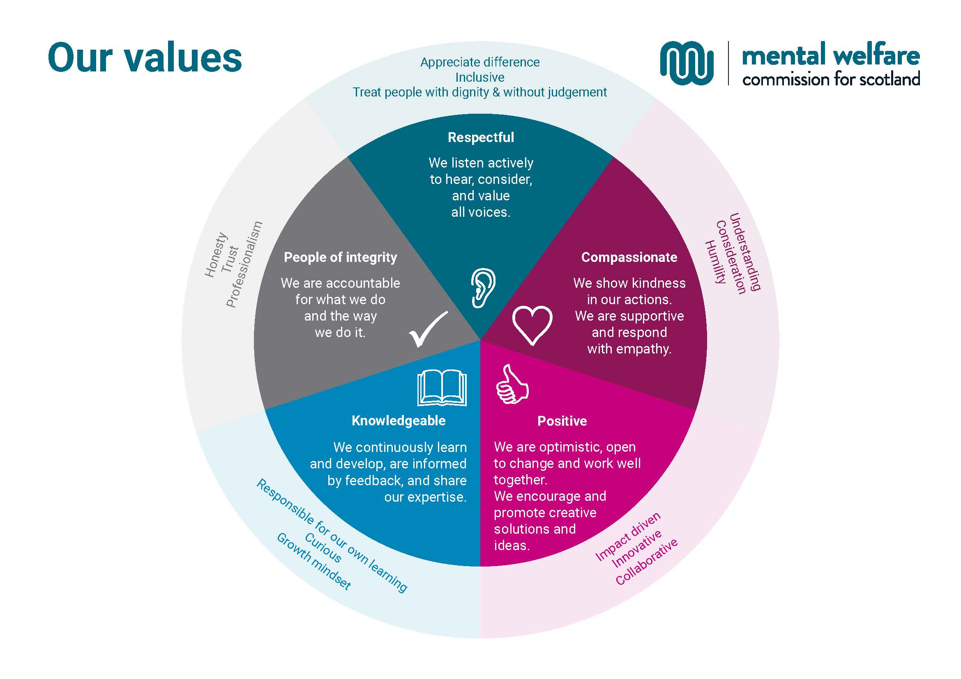

Quality Assurance Engineer

£46,459 - £51,621 per annum

35 hours per week

This post is offered on a Fixed Term

Hybrid working

The Commission protects and promotes the human rights of people with mental illness, learning disabilities, dementia, and related conditions.

This is an interesting new role; you will primarily be responsible for managing the testing architecture for a new cloud software solution that will be developed and configured to deliver a case management system for the Commission. This post will include engaging with technical, non-technical stakeholders and the development team.

You will have substantial experience as a Quality Assurance Engineer in cloud software development, with a methodological and disciplined approach to testing and data validation within an agile environment. You will have a proven track record of delivering successful software applications though comprehensive testing strategies.

At the Commission we champion diversity, inclusion, and wellbeing. We pride ourselves on being an employer of choice, cultivating a sense of belonging and providing a workplace where everyone feels valued. We aim to have a workforce which represents the wider society that we serve and therefore encourage applications from people of all backgrounds and under-represented groups.

Our office environment is modern, light, bright and green with superb views and is very close to Haymarket Railway station and transport links.

For an informal discussion about this vacancy, please contact Gail Devaney, on gail.devaney@nhs.scot who will arrange a suitable time to contact you.

For more information on applying, please visit the website at https://www.mwcscot.org.uk/about-us/work-us

Please apply by 12 noon on Monday13 April 2026. Interviews will be arranged for short-listed candidates on Tuesday 21 April 2026.

Quality Assurance Engineer role - Job Description

Job Title: | Quality Assurance Engineer
Reports To: | Project Manager
Direct Reports: | None

- Job Purpose
The organisation is replacing its patient record management IT system.

The Quality Assurance Engineer, as an essential member of the Project Team, will play a key role in ensuring the quality of the functionality and data of the new software solution and will collaborate with developers and work closely with internal stakeholders to assess development before providing sign-off.

- Dimensions
There are approximately 90 staff employed in the Commission with various work patterns and working arrangements including hybrid working.
The Commission’s office is based in Edinburgh, but practitioner and engagement staff work across the different geographical areas in Scotland.
The staff group includes senior managers, doctors, nurses, social workers, researchers, administration, communication, engagement, IT, finance and business professionals.
The post-holder will be working with the business, internal IT colleagues, and the supplier development team to deliver quality software products as part of the Project Team.
The Project team has an Executive Director Social Work Lead, Project Manager, Assistant Project Manager/Business Change Analyst, Business Analyst and Project Support Administrator along with other disciplines represented in the Project.
As the Commission is a small organisation, the staff employed develop a wide range of skills, experience, and speciality, which in a larger organisation would have several specialised posts or even whole departments.

The post-holder will work alongside business, technical and external colleagues to fully test the new Information Management System that will serve to monitor the use of the Mental Health (Care and Treatment) (Scotland) Act 2003 and other relevant legislation throughout Scotland, in addition to managing information in relation to the Commission’s investigation, visits, information and adviceline and case management activities.

- Role of the Mental Welfare Commission for Scotland
We protect and promote the human rights of people with mental illness, learning disabilities, dementia and related conditions.

We do this by:

- Checking if individual care and treatment is lawful and in line with good practice.
- Empowering individuals and their carers through advice, guidance and information
- Promoting best practice in applying mental health and incapacity law
- Influencing legislation, policy and service development

4. Key Result Areas
The post-holder will work on a new cloud software development project and be responsible for ensuring the quality and functionality of the new solution.
The Primary responsibilities of the job are:
- Work with the project management team in establishing a test governance model, test strategy for integration and end to end testing.
- Review the business requirement and functional specifications to create detailed and effective test plans.
- Independently develop, update, and execute test cases based on requirements whilst meeting project deadlines.
- Identify issues in functionality and data and oversee the issue resolution and retest.
- Ensure traceability from requirements via creation of test artefacts such as the Test Strategy document, Testing progress report and Test summary documents.
- Have a key focus on Data quality and application security validation.
- Actively participate in the Agile scrum delivery process.
- Actively report and summarize test results to the team, including other testers, developers, and stakeholders.
- Have a detailed understanding of secure coding practices, encryption, authentication, and network security anticipating risk and testing security strategies to protect sensitive information.
- Must be adept at testing systems in a cloud environment such as Azure or Google platform.

- Planning and organising
The post-holder will prioritise and manage their own workload in conjunction with the test team and report directly to the Project Manager.

The post-holder will work autonomously across the organisation and engage with key stakeholders and the developers of the new system.

- Internal and External Relationships
In addition to the Project Manager as line manager, the key internal relationships are:

Business Analysts – to understand the requirements and communicate effectively with the wider team, defining the acceptance criteria, influence user acceptance testing and activities to review for acceptance tests.

Systems Analysts – to gain an understanding of the gathered requirements and the current database and casework system, high level of involvement in system testing.

Casework Manager – to gain an understanding of how the Casework Team utilise the current patient database and casework system, has a high interest in the outcome of the testing.

Executive Directors– to gain an understanding of how the practitioners (nursing, social work and medical) utilise the current patient database and casework system and enabling definition of the appropriate test approach.

Casework administrators and practitioners - to define current processes and scope improvements for the new system, will influence and carry out user acceptance testing and the testing outcomes.

Key external relationships

- Medical records staff – to engage with medical records staff to optimise testing strategy and influence and carry out user acceptance testing.

- Designated Medical Practitioners – to engage with DMPs to optimise testing strategy and influence and carry out user acceptance testing.

- Senior staff in key partner organisations such as Mental Health Tribunal Service, Office of the Public Guardian, Scottish Courts and Tribunal Service, Police Scotland and Scottish Government to optimise testing strategy and influence and influence and carry out user acceptance testing.

- Suppliers Designers – to conduct design review, usability testing, accessibility texting before the development begins.

- Suppliers Developers – to fix defects and define quality measures.

- Most Challenging Aspects of the Job
- Responsibility for the QA functions, creating and executing the test strategy while ensuring the project stays on track.
- Responsibility for ensuring that the design meets the quality standards and is testable.
- Focusing on the best possible test coverage and being able to help inexperienced team members with well documented processes, test cases and execution strategies.
- Developing a strong understanding of the Business and being able to implement the understanding in terms of test coverage.

- Skills/Qualifications and Experience
- A bachelor's degree in computer science, information technology, or a related field experience
- 5+ year of experience as a software test engineer.
- Strong communication skills to promote confidence and efficiency in the workplace.
- Ability to work independently and collaboratively within the project team.
- Experience of testing in a SaaS cloud development environment.
- Proven testing and quality assurance background with detailed understanding of the Agile software development life cycle and best practices.
- Experience in Data validation via SQL or similar query language.
- Experience API testing via Postman or similar applications.
- Experience writing and executing non-functional test scripts, focus on performance.
- Experience in migration testing and cross browser validation.
- Experience of testing relating to disaster recovery capabilities of the system
- Understanding of browsers and client-side technologies, browser/application server interactions

Person specification
Essential Criteria | Application | Interview
Bachelor’s degree in computer science or related experience | x
5+ years’ experience in software quality assurance | x
Proven problem solving, communication, analytical and interpersonal skills with a meticulous eye for detail. | x | x
Working experience of software test tools and processes, building testing frameworks, and applications. | x | x
Working knowledge of an Agile software development life cycle and experience in using tools such as Jira. | x | x
Ability to work independently and collaboratively within a team. | x | x
Creating and maintaining test data and the environment effective logging, monitoring and retesting of all defects found. | x | x
Experience in Data validation using structured query languages such as SQL. | x | x
Experience in API validation using software such as Postman. | x | x
Experience in Cross browser validations and understanding of browsers and client-side technologies, browser/application server interactions. | x | x
Desirable Criteria
Experience of testing relating to disaster recovery capabilities of the system | x | x
Experience in Automation Via Software such as Selenium. | x | x

Employment Information – Quality Assurance Engineer

The following notes summarise the key points of the terms and conditions.

Full details will be provided with offers of employment.

Headquarters | Thistle House, 91 Haymarket Terrace, Edinburgh, EH12 5HE (hybrid working options)
Pay | £46,459 - £51,621 per annum
Type of Contract | This post is offered on a fixed term basis for a period of up to 12 months.  Applications will also be considered for a secondment opportunity. Agreement, in principle, should be obtained from your parent organisation prior to application.
Manager | Post-holder reports to the Project Manager
Hours of work | Full-time posts are 5-days per week of 35 hours, exclusive of breaks but the hours of attendance may be varied, by agreement, to meet the needs of the work.
Leave | Annual Holidays  The annual entitlement for full time posts is 25 days per year, rising to 30 days after 10 years’ relevant service. (NHS and local authority service is counted as relevant service). Leave entitlement is pro-rata for part-time posts.  General/Public Holidays  Public and privilege holidays total 11.5 days per leave year, 6 of these are on set dates and the remainder can be taken as required.  For part time posts, the public/privilege holiday entitlement is pro-rata to full time equivalent.  The leave year runs from 1st April to 31st March.
Superannuation | NHS Pension Scheme is available to all staff subject to scheme rules.  Please click here for contributions details.  The employer currently contributes an amount equal to 22.5% of pensionable pay into the scheme on members’ behalf.
Staff Benefits | Through the Commission Staff Benefits scheme there is access to a wide variety of offers and discounts from the UK’s most popular retailers and service providers. The current provider is EdenRed. There is also access to, My Gyms discount site, the UK's largest network of gyms, studios, fitness centres and sports clubs across the UK with discounted membership offers. A comprehensive Employee Assistance Programme is also available and access to a Cycle to Work Scheme.  (The Commission reserves the right to withdraw, amend the schemes and change providers as appropriate)
Our values | The Commission operates a set of internal values for staff.
Performance, Learning and Development | There is a performance development system in operation within the Commission. Progression through the salary scale is subject to satisfactory performance.
Data protection | The information you provide on the application form and any supplementary forms will be used to assist in the process of recruitment and selection in accordance with the Policy of the Mental Welfare Commission.  If you are successful in your application the information you provide will be used for HR and Payroll purposes. By signing the declaration section of the application form it is understood that you consent to the use and storage of your personal information for the above stated purposes.
Work outside the Commission | It is important to identify and minimise any conflicts of interest that could prevent staff from making fair and objective judgements or could be perceived as doing so by people with lived experience and carers, practitioners and the public. Details are contained in the Commission’s Conflict of Interest Policy. Please note that employees may not be members or employees of the Mental Health Tribunal for Scotland while working for the Commission.
Probationary period | The post requires a 6 months’ probationary period.
Disclosure Scotland | You will be required to submit an update application for a PVG Certificate Children & Adults.
Complaints | The Commission has a Complaints Handling Procedure. All applicants have access to it if they feel they have been unfairly treated during the recruitment and selection process. External applicants should direct any concerns to the Human Resources department and internal applicants have recourse to the Commission’s Grievance Procedure.
Equal opportunities | The Commission is an equal opportunities employer.
Feedback | We do recognise the time and effort it takes to apply for a position. Following the short-listing process, you will be notified about the outcome of your application by email.

How to Apply

The Mental Welfare Commission encourages applications from all sections of the community.

We hope the information we have provided will encourage you to find out more about this opportunity.

To apply please complete the application form and email along with a CV to mwc.recruitment@nhs.scot

Please apply by 12 noon on Monday 13 April 2026. Interviews will be arranged for short-listed candidates on Tuesday 21 April 2026.

